**UNIT 1**

1. Which of the following requires a routine and regular review and evaluation of the data

a) Data quality assurance

b) Big data

c) Software quality assurance

d) Software project management

2. To represent Annual seasons, 24-hour days, and biological processes such as the Krebs Cycle, which of the following charts can be used?

a) Circular layout

b) Rectangle layout

c) Square layout

d) Hierarchy layout

3. Not manually drawn, aesthetically poor and relatively data-rich are the characteristics of __________.

a) Machine learning

b) Infographics

c) Data visualization

d) Bigdata

4. Which of the following is NOT an example of structured data?

a) Captured data

b) Created data

c) Compiled data

d) Transactional data

5. Which of the following is NOT used to represent data quality?

a) Accuracy

b) Relevance

c) Appropriateness

d) Visual art

6. Two categories of data visualization are __________ and ______________.

a) Infographics and visual arts

b) Exploratory and explanatory

c) Subjective and Objective

d) Splunk and SPL

7. Which files are used to explore operational intelligence?

a) Log files

b) Temporary files

c) Metadata

d) HTML files

8. Manually drawn, aesthetically rich and relatively data-poor are the characteristics of __________.

a) Data viz

b) Infographics

c) Tableau

d) Splunk

9. Increasing order of volume of data is __________.

a) Gigabyte->Yottabyte->Petabyte-> Exabyte

b) Megabyte->Terabyte->Exabyte->Yottabyte

c) Petabyte-> Terabyte->Yottabyte->Zettabyte

d) Yottabyte->Exabyte->Gigabyte->Terabyte

10. What are the pros of data visualization?

a) It can be accessed quickly by a wider audience.

b) It can misrepresent information

c) It can be distracting

d) No pros in data visualization

11. Requesting a customer to fill out a review form is considered as _____________

a) Provoked data

b) Compiled data

c) Captured data

d) User-generated data

12. Which of the following data is passively created?

a) Search term on Google.

b) Recording a sales transaction

c) Account creation

d) Experimental data

PART B / PART C

1. Differentiate Infographics and data visualization.

2. Discuss the approaches to data visualization.

3. List the challenges of big data visualization.

4. Apply natural ordering and distinct values to the visual property.

5. Differentiate structured and unstructured data. List some examples for the same.

6. List some of the common visualization methods.

7. Explain natural ordering and distinct values of the visual property.

8. Show the relationship between Informative, persuasive and Visual art.

9. Discuss when to use defaults and innovative formats.

10. Show the relationship between data, designer, and reader.

**UNIT II**

1. A data set has been read in R and stored in a variable “df01”. Which of the below codes will produce a summary (mean and mode) of the entire dataset in a single line of code?

a) summary(df01)

b) stats(df01)

c) summarize(df01)

d) summarise(df01)

2. Which of the following code would read 100 rows?

a) initial <- read.table(“datatable.txt”, nrows = 100)

b) tabAll <- read.table(“datatable.txt”, colClasses = classes)

c) initial <- read.table(“datatable.txt”, nrows = 99)

d) initial <- read.table(“datatable.txt”, nrows = 101)

3. In R programming, If you explicitly want an integer, you need to specify the _____ suffix.

a) D

b) R

c) L

d) I

4. Which of the following function is used to view the dataset in spreadsheet like format?

a) disp()

b) view()

c) seq()

d) showsheet()

5. Data Manager supports reading from various …………………..data sources for greater flexibility.

1. O**pen Database Connectivity (ODBC)**
2. Java Database Connectivity (ODBC)
3. Components-based
4. ActiveX control
5. Which script is used to execute external commands in the data manager?
6. Java Script
7. Python
8. R script
9. Visual Basic Script (VBScript).
10. ______ is used to describe the range, variance, and standard deviation of the dataset.

a) **Dispersion**

b) Compare

c) Contrasts

d) Tendencies

8. Which SQL function is similar to the table function in R?

a) group by

b) sort

c) where

c) count

9.Which tool uses hundreds of nodes and multiple Inputs and Output nodes to create very straightforward design?

1. Data manager
2. R tool
3. Tableau
4. D3

10.Which node allows to run external applications from within Data Manager after an Output File node has executed?

1. Run
2. ExecCmd
3. SelectRow
4. HasHeader

11. In which command is used to view the first n number of rows in R?

a) count

b) search

c) head

d) nrow

12. Which of the following is true about R?

A. R is a well-developed, simple and effective programming language  
B. R has an effective data handling and storage facility  
C. R provides a large, coherent and integrated collection of tools for data analysis.  
D. All of the above

**PART B/PART C**

1. Explain how to import or read a CSV file into a data frame in R.
2. Explain the ways to calculate the mean of a CSV file in R.
3. Consider the medical data set and group the hospital visits by the age of the patients. Write an R code to implement the age ranges and create the following pie chart visualization.

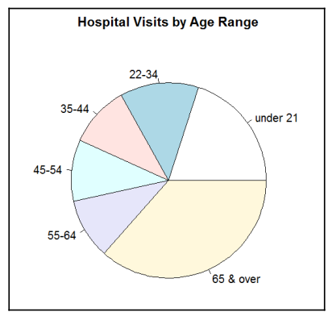

1. Consider the medical data set and write an R code to calculate BMI from the existing patient information such as the patient's weight and height.
2. Explain the three types of nodes in the data manager with a neat diagram.
3. Discuss how data quality can be assessed in a data manager. Explain with an example.
4. List the advantages and disadvantages of R.
5. Compare data manager and R.
6. An Online Survey collected the medical data set. The file includes many fields such as Patient_ID, Sex, Date_of_Birth, age, Height, weight, Bloodtype, Blood_pressure, Heart_rate, Smoker, Non_smoker, No_of_hospital_vist, State, Country_code, Phone_no. Data Profiling and Data Visualization need to be performed from the given data fields using R Programming.

Display the number of rows in the medical data set.

Create the bar chart data visualization hospital visits by sexas the title.

Create a scatter plot data visualization of hospital monthly visits by age group.

1. Calculate BMI from the existing patient information such as the patient's weight and height without looping using R.
2. Explain update status and relevance in data manger with an example.
3. Discuss how data completeness affects the quality level of the data in data manager?
4. Discuss the important parameters used in pie() in R.
5. Discuss the important parameters used in barplot() in R.
6. Differentiate Filler and Filter nodes found in Work nodes in the data manager tool. Explain with an example.
7. Create a boxplot in R with data X = (34, 23, 45, 89, 35, 67, 100, 03, 45). The title of the chart should be “My Plotting”. X-axis labelled as “Nature of Graph”. Y-axis labelled as “Range of values”. Colour of the axis should be in red.

**UNIT III**

1. Which Tableau product offers more options for data profiling, preprocessing, and manipulation?
2. Desktop
3. Trifacta
4. VizQL
5. SQL
6. Which is the shortcut for swap or flip the sheets visualization from a vertical to a horizontal display in Tableau?
7. Ctrl - W
8. Ctrl - S
9. Ctrl - H
10. Ctrl – V
11. Which option is used to add calculations directly to a visualization?
12. Create Calculated Field
13. Data pane
14. Measures
15. Dimensions
16. Which Tableau extension is suitable to save all the sheets and their connection information in a workbook file?

a) .twbx

b) .twb

c) .twbs

d).twbv

1. Which Tableau extension is suitable to save all the sheets, their connection information, and any local resources?
2. .tw**bx**
3. .twb
4. .twbs
5. .twbv
6. Which tool is used to consume prepared data and create valuable visualizations as individual components of interactive dashboards?
7. Data manager
8. Tableau
9. R
10. Python
11. Tableau combines which languages for database visualization.
12. SQL, JAVA
13. ORACLE, JAVA
14. SQL, VizQL
15. ORACLE, VizQL
16. Which is a collection (of worksheets and supporting information) shown in a single place?
17. Sheets
18. Objects
19. Dashboard
20. Dimensions

9. What are the components of a Dashboard?

1. a) Horizontal
2. b) Vertical
3. c) Image Extract
4. d) All of the Above

10. How does the user identify a continuous field in Tableau?

1. a) It is identified by a blue pill in the visualization.
2. b) It is identified by a green pill in a visualization.
3. c) It is preceded by a # symbol in the data window.
4. d) When added to the visualization, it produces distinct values

11. Which of the following is NOT a Tableau version type?

1. a) Tableau Desktop
2. b) Tableau Public
3. c) Tableau Reader
4. d) Tableau Express

12. Which of the following is NOT a Tableau Field data type?

1. a) Number (whole)
2. b) String
3. c) Date & Time
4. d) Float

**PART B/PART C**

1. What is Tableau, and what are its primary features?
2. What are the different types of charts and graphs that can be created in Tableau?
3. Differentiate Join and union in Tableau.
4. List the different types of file types and their extensions in detail.
5. Compare dimensions and measures with an example.
6. Explain in detail about various data types in tableau.
7. How will you import a dataset in Tableau?
8. Consider the following productSalesPromotionBurn table and write the procedure to draw the data pane, visualize the Promotion type as columns, Measure Values (the monthly promotion burn total) as rows, and Save the workbook.

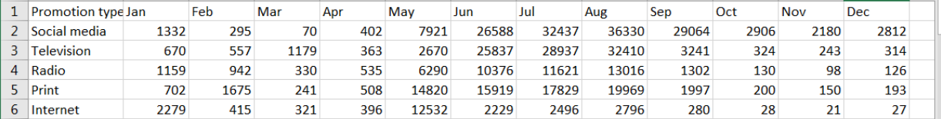

1. Consider the following totals table, create new column as indicator using Create Calculated Field and display the output. The formula indicates that if the value of the current cell in the Change column is positive (greater than zero) then it's Up from the prior year (otherwise it is Dn from the prior year).

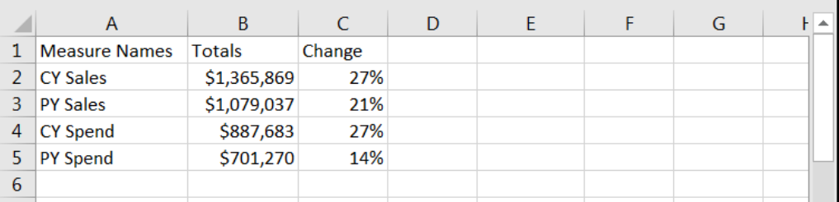

1. Explain in detail about the data wrangling and the issues arise in Trifacta Script panel with an example.
2. Explain in detail about Tableau dashboard with an example.
3. Consider the following productSalesPromotionBurn table, write the procedure to visualize product sales only on Jan, Feb and March, bar plot as the visualization type and display the visualization using Tableau.



1. Consider the following table and add new column as Percent of Sales field, Select Line as the visualization type, Edit the Title and Axis text, Save the worksheet and display the visualization using Tableau.

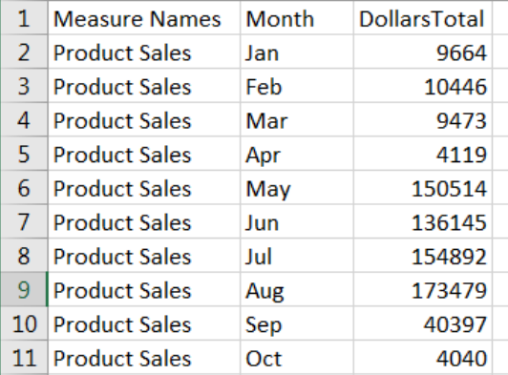

1. Discuss in detail about re-coloring, resizing and adding or changing labels in Tableau with an example.
2. Explain in detail about changing the type of visualization and adding calculation formulas in Tableau with an example.

**UNIT IV**

1. Which is actually an open-source JavaScript library, designed with the intention of visualizing data using today's web standards?
2. D3
3. D3.js
4. D3.java
5. Both a and b
6. In Visual transitions, which button is used to change the format of the visualization.
7. Reset
8. Radio
9. Submit
10. Select
11. When dealing with manufacturing data, which is collects production data directly from the machine, stores it in memory, and periodically sends it off to the data repository?
12. Data manager
13. Data logger
14. Data Aggregator
15. Data handler
16. Visual transitions handle missing data by filling
17. Null values
18. Zeros
19. Either null or zero
20. None of the above
21. The procedure of clicking on the HTML radio buttons to change the format of the visualization is known as …………….
22. Transitioning
23. Transforming
24. Slicing
25. Indexing
26. In D3, Which tool is preferred to easily aggregate data and then merge the multiple aggregated files into a single file for visualization?

a) Splunk

b) R

c) Python

d) Data Manager

7. D3 helps put life into your data by utilizing

1. Scalable Vector Graphics (SVG)
2. Canvas
3. Standard HTML
4. All of the above

8. JavaScript functions are used to read other data format in --------------------

a) R

b) Data Manager

c) Splunk

d) D3

9. D3.js stands for ____.

1. Data document and dom manipulation
2. Data-driven documents
3. Dom data documents
4. Document-driven data

10.In d3.js, a ____ is a collection of DOM items that match a particular selector.

1. Selection
2. Path
3. Events
4. Transition

11.The ____ function adds a new element as the final child of the current selection's element.

1. End()
2. Add()
3. AddLast()
4. Append()

12. A smooth, animated shift in the look or behavior of components in visualization is referred to as a ____ in d3.js.

1. Events
2. Transition
3. Layout
4. Selection

**PART B/PART C**

1. The following table shows the total number of products produced for each machine ID, broken out by shift. Create the bar chart and write the procedure to visualize the total pieces and Machines using D3.

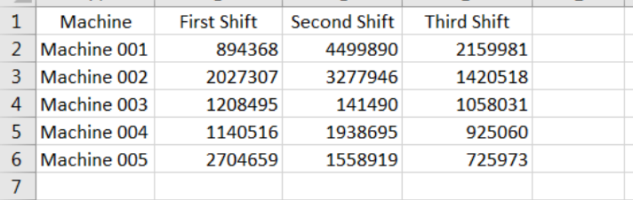

1. The following screenshot shows a portion of our raw data. Write an R code to aggregate the part counts by shift ID to a summary file then visualize output by shift using D3.

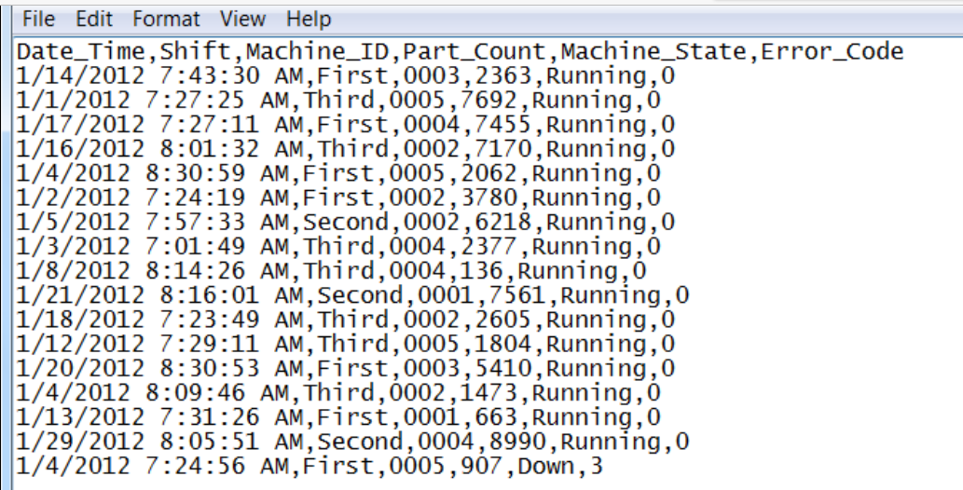

1. Explain the procedure to convert Stacked-to-Multiples using D3 with an example.
2. Discuss the features used in Stacked Area via Nest example for better visualization.
3. Differentiate domain, range, and scale in D3.
4. Compare the usage of Canvas and SVG in d3.js.
5. Create the web page with your name and department using d3.js
6. Apply transitions and visualize the relationship between apples and oranges by donut pie chart using D3.

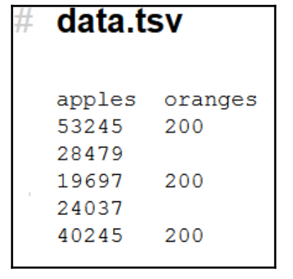

1. Apply transitions, show the ability to change the shift and display the visualization update by donut pie chart using D3.

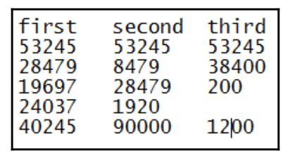

1. Explain the steps to handle negative values using D3.
2. Explain the procedure to draw Multiple donuts chart using D3 with an example.
3. Explain in detail how D3.js selects the method.
4. Explain visual transition in D3 with an example.
5. Demonstrate multiple donuts chart using D3 with an example.

**UNIT V**

1. …………….are free, online, and sharable, allowing multiple people to edit.

a) Google Spreadsheets

b) Adobe Illustrator

c) Tableau

d) Python

2 ………………..is a popular out‐of‐the‐box data visualization solution that can be great for exploratory analysis and it is expensive.

a) Tableau

b) data manager

c) R

d) python

**3.** Some people use……………., either alone or together Excel or via a programming language, for easier manipulation of graph elements and a professional look and feel.

a) Adobe Illustrator

b) Adobe Photoshop

c) Adobe editor

d) Adobe pdf

4. This site allows you to submit a visual to receive feedback from readers or scan the archives for examples and corresponding conversations.

a) VizWiz

b) Junk Charts

c) HelpMeViz

d) Eager Eyes

5. In which background support to focus data easily?

a) White background

b) Dark background

c) Light Element on Dark Background

d) None of the above

6. A ……………is a line graph where the lines overlap a lot, making it difficult to focus on a single series at a time.

a) donut pie graph

b) Bar graph

c) spaghetti graph

d) scatter graph

7. …………….are free, online, and sharable, allowing multiple people to edit.

a) Google Spreadsheets

b) Adobe Illustrator

c) Tableau

d) Python

8. ………………..is a popular out‐of‐the‐box data visualization solution that can be great for exploratory analysis and it is expensive.

a) Tableau

b) data manager

c) R

d) python

1. In which background support to focus more on background?

a) White background

b) Dark background

c) Light Element on Dark Background

d) None of the above

10. Which Programming language does not support greater flexibility and control of the specific elements of the graphs?

a) R

b) D3 (JavaScript)

c) Python

d) Java

11. Some people use……………., either alone or together Excel or via a programming language, for easier manipulation of graph elements and a professional look and feel.

a) Adobe Illustrator

b) Adobe photoshop

c) Adobe editor

d) Adobe pdf

12. This site allows you to submit a visual to receive feedback from readers or scan the archives for examples and corresponding conversations.

a) VizWiz

b) Junk Charts

c) HelpMeViz

d) Eager Eyes

**PART B/PART C**

1. Describe the five steps for storytelling of data visualization.
2. Explain in detail about leveraging animation in the visuals you present.
3. Illustrate how color can impact the overall tone of a visualization with an example.
4. Illustrate how color can impact the overall tone of a visualization with an example.
5. You work at a company that sells a product that has various features. You’ve recently surveyed your users to understand whether they are using each of the features and how satisfied they’ve been with them and want to put that data to use. How satisfied have you been with each of these features? Justify the statement “There should be logic in the order of the data you show”.
6. Explain the strategies for leveraging animation in the visuals you present.
7. Discuss the strategies for avoiding the spaghetti graph.
8. Discuss the strategies for taking information from the would‐be‐spaghetti graph.
9. Explain in detail about leveraging animation in the visuals you present.
10. Outline the five steps for storytelling with the data process.